sno

The Palestine Monitor
The Voice of Civil Society

Palestinian Intifada - 4th Anniversary
PRESS CONFERENCE
Dr. Mustafa Barghouthi Director HDIP
Secretary General of the Palestinian National Initiative

3,334 Palestinians killed by Israeli forces
28 September, 2000 – 25 September, 2004

Month of Intifada | Dates | Number killed
37 | Sep 28 – Oct 27, 2003 | 54
38 | Oct 28 – Nov 27 | 31
39 | Nov 28 – Dec 27 | 54
40 | Dec 28 – Jan 27, 2004 | 21
41 | Jan 28 – Feb 27 | 58
42 | Feb 28 – Mar 27 | 96
43 | Mar 28 – Apr 27 | 56
44 | Apr 28 – May 27 | 111
45 | May 28 – June 27 | 39
46 | June 28 – July 27 | 67
47 | July 28 – Aug 27 | 42
48 | Aug 28 – Sept 25 | 69
Total |  | 698
Year of  Intifada | Dates | Number killed
1 | Sept. 2000 – Sept. 2001 | 714
2 | Oct. 2001 – Sept. 2002 | 1,195
3 | Oct. 2002 – Sept. 2003 | 727
4 | Oct. 2003 – Sept. 2004 | 698
Total |  | 3,334

See opposite for breakdown of months this year.

Breakdown of all 3,334 Palestinian Deaths
Palestinian Intifada 4th Anniversary

Deaths by Residential District | # | % |  | Site of Body Injury | # | %
Bethlehem | 127 | 3.81 |  | Head and neck  (Including 17 from behind) | 699 | 20.97
Gaza | 1,598 | 47.93 |  | Chest  (Including 51 from behind) | 485 | 14.55
Hebron | 232 | 6.96 |  | Abdomen | 152 | 4.56
Inside Green Line | 20 | 0.6 |  | All over body | 1,454 | 43.61
Jenin | 331 | 9.93 |  | Lower limb | 26 | 0.78
Jericho | 11 | 0.33 |  | Unknown/unspecified/Not Applicable | 518 | 15.54
Jerusalem | 39 | 1.17 |  | Immediate Cause of Death | # | %
Nablus | 450 | 13.5 |  | Live ammunition* | 1,996 | 59.87
Qalqilya | 64 | 1.92 |  | Heavy weapons** | 742 | 22.26
Ramallah | 165 | 4.95 |  | Rubber-coated metal bullets | 3 | 0.09
Salfit | 3 | 0.09 |  | Prevention of medical treatment | 86 | 2.58
Tulkarem | 194 | 5.82 |  | Tear gas | 20 | 0.6
Unknown | 94 | 2.82 |  | Other/Unknown*** | 487 | 14.61
Abroad  (Jordan & Egypt) | 6 | 0.18 |  | * Includes 5.56 mm (223 caliber) bullets, 7.02 mm bullets, 9 mm bullets, 50 caliber bullets, 500 mm bullets, 800 mm bullets.  ** Includes tank fire, bombs, missiles from helicopter, and F-16’s.  *** Includes explosions, being hit by car or stabbed, or having a heart attack after being attacked or unknown.
Age of those Killed
17 and Under | 621 | 18.63
18 and Over | 2,575 | 77.23
Unknown | 138 | 4.14

An estimated 53,000 Palestinians have been injured
2,500 of those are permanently disabled,
10,000 of those were children

209 Palestinian women and girls killed by Israeli forces 28 September, 2000 – 25 September, 2004
Palestinian Intifada 4th Anniversary
Palestinian Intifada 4th Anniversary
Female Deaths by Residential District | # | % |  | Site of Body Injury | # | %
Bethlehem | 10 | 4.78 |  | Head and neck | 38 | 18.18
Gaza | 93 | 44.5 |  | Chest  (Including 1 from behind) | 32 | 15.31
Hebron | 12 | 5.74 |  | Abdomen | 5 | 2.39
Inside Green Line | 2 | 0.96 |  | All over body | 80 | 38.28
Jenin | 26 | 13.88 |  | Lower limb | 1 | 0.48
Jericho | 1 | 0.48 |  | Unknown/unspecified/Not Applicable | 53 | 25.36
Jerusalem | 1 | 0.48 |  | Immediate Cause of Death | # | %
Nablus | 31 | 14.83 |  | Live ammunition* | 77 | 36.84
Qalqilya | 3 | 1.43 |  | Heavy weapons** | 61 | 29.19
Ramallah | 20 | 9.57 |  | Rubber-coated metal bullets | - | -
Tulkarem | 6 | 2.87 |  | Prevention of medical treatment | 29 | 13.88
Unknown | 4 | 1.91 |  | Tear gas | 6 | 2.87
Age of Females Killed |  |  |  | Other/Unknown*** | 36 | 17.22
17 and Under | 74 | 35.41 |  | * Includes 5.56 mm (223 caliber) bullets, 7.02 mm bullets, 9 mm bullets, 50 caliber bullets, 500 mm bullets, 800 mm bullets.  ** Includes tank fire, bombs, missiles from helicopter, and F-16’s.  *** Includes explosions, being hit by car or stabbed, or having a heart attack after being attacked or unknown.
18 and Over | 132 | 63.16

Arrests & Detention
Since the beginning of the occupation in 1967, over 650,000 Palestinians have been detained by Israel accounting for 40% of the total male population.
- Since Sep. 2000 more than 28,000 Palestinians have been arrested and detained.
- The IDF & Israel prison service currently hold close to 8,000 Palestinians.
- 2,300 have been charged.
- Some 3,700 are still awaiting trial.
- 1,200 are being held in administrative detention which is renewed regularly.
- There are now altogether approximately 100 Palestinian women political prisoners

Palestinian child detainees
- At least 2,500 children have been arrested & detained since the beginning of the intifada
- Approximately 377 Palestinian children are currently detained
- 31 child detainees suffer diseases
- 78 children are being held under administrative detention
- 80% of detained children were subject to torture

Breakdown of 621 Palestinian children killed by Israeli forces
Palestinian Intifada 4th Anniversary
28 September, 2000 – 25 September, 2004

Child Deaths by Residential District | # | % |  | Site of Body Injury | # | %
Bethlehem | 21 | 3.38 |  | Head and neck  (Including 5 from behind) | 200 | 32.21
Gaza | 331 | 53.3 |  | Chest  (Including 15 from behind) | 131 | 21.11
Hebron | 39 | 6.28 |  | Abdomen | 38 | 6.12
Inside Green Line | 1 | 0.16 |  | All over body | 168 | 27.05
Jenin | 59 | 9.5 |  | Lower limb | 2 | 0.32
Jericho | 1 | 0.16 |  | Unknown/unspecified/Not Applicable | 82 | 13.2
Jerusalem | 7 | 1.13 |  | Immediate Cause of Death | # | %
Nablus | 82 | 13.2 |  | Live ammunition* | 411 | 66.18
Qalqilya | 11 | 1.77 |  | Heavy weapons** | 118 | 19
Ramallah | 35 | 5.63 |  | Rubber-coated metal bullets | 2 | 0.32
Tulkarem | 29 | 4.67 |  | Prevention of medical treatment | 30 | 4.83
Unknown | 5 | 0.81 |  | Tear gas | 6 | 0.97
 |  |  |  | Other/Unknown*** | 54 | 8.7
* Includes 5.56 mm (223 caliber) bullets, 7.02 mm bullets, 9 mm bullets, 50 caliber bullets, 500 mm bullets, 800 mm bullets.
** Includes tank fire, bombs, missiles from helicopter, and F-16’s.
*** Includes explosions, being hit by car or stabbed, or having a heart attack after being attacked or unknown.

424 Palestinians have died in extra judicial assassinations
Palestinian Intifada 4th Anniversary
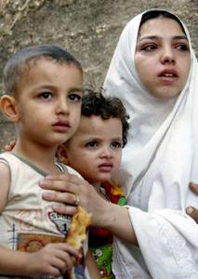
28 September, 2000 – 25 September, 2004

Assassinations | # | %
Target | 238 | 56.1
Bystander | 186 | 43.9

Bystander | # | %
Women | 26 | 13.98
Children | 39 | 20.97

Assassinations by District | Target | Bystander | Total # | %
Bethlehem | 8 | 11 | 19 | 4.48
Gaza | 72 | 118 | 190 | 44.8
Hebron | 16 | 4 | 20 | 45.45
Inside Green Line | - | 1 | 1 | 0.24
Jenin | 41 | 12 | 53 | 12.5
Jericho | 2 | - | 2 | 0.47
Jerusalem | 1 | - | 1 | 0.24
Nablus | 55 | 19 | 74 | 17.45
Qalqilya | 10 | - | 10 | 2.36
Ramallah | 7 | 9 | 16 | 3.77
Tulkarem | 25 | 12 | 37 | 8.73
Unknown | 1 | - | 1 | 0.24
 | 238 | 186 | 424

Israel's Assassination Policy

International law prohibits without exception, the extra-judicial killing of protected persons. Israel's policy of assassination clearly amounts to intentional or wilful killing, which constitutes a grave breach of the Fourth Geneva Convention and is subject to international criminal prosecution.

Palestinian Intifada 4th Anniversary
Breakdown of Palestinian and Israeli deaths
during period of ‘relative calm’ March 14 2004 – August 31 2004

During this ‘lull’ in violence, 361 Palestinians were killed, 71 in extra-judicial assassination attacks including the killings of the two highest ranking Hamas leaders, Abdel Aziz Rantissi and Sheikh Ahmed Yassin. The deaths of whom Hamas claimed to be revenging with the bombings in Beersheba. At least 26 of the 73 killed in assassinations were not Hamas leaders, they were not Al Aqsa Brigades or associated with any of the groups targeted for resisting the illegal occupation. They were women and children, innocent bystanders.
- Of the 31 Israelis killed in this five month period, 18 were soldiers and 10 were settlers.

- Of the 361 Palestinians killed in this period 45% were civilians
- 74 were children
- 16 were women

In May alone Israel’s incursions into the Gaza Strip, including its “Operation Rainbow” killed 75 Palestinians.

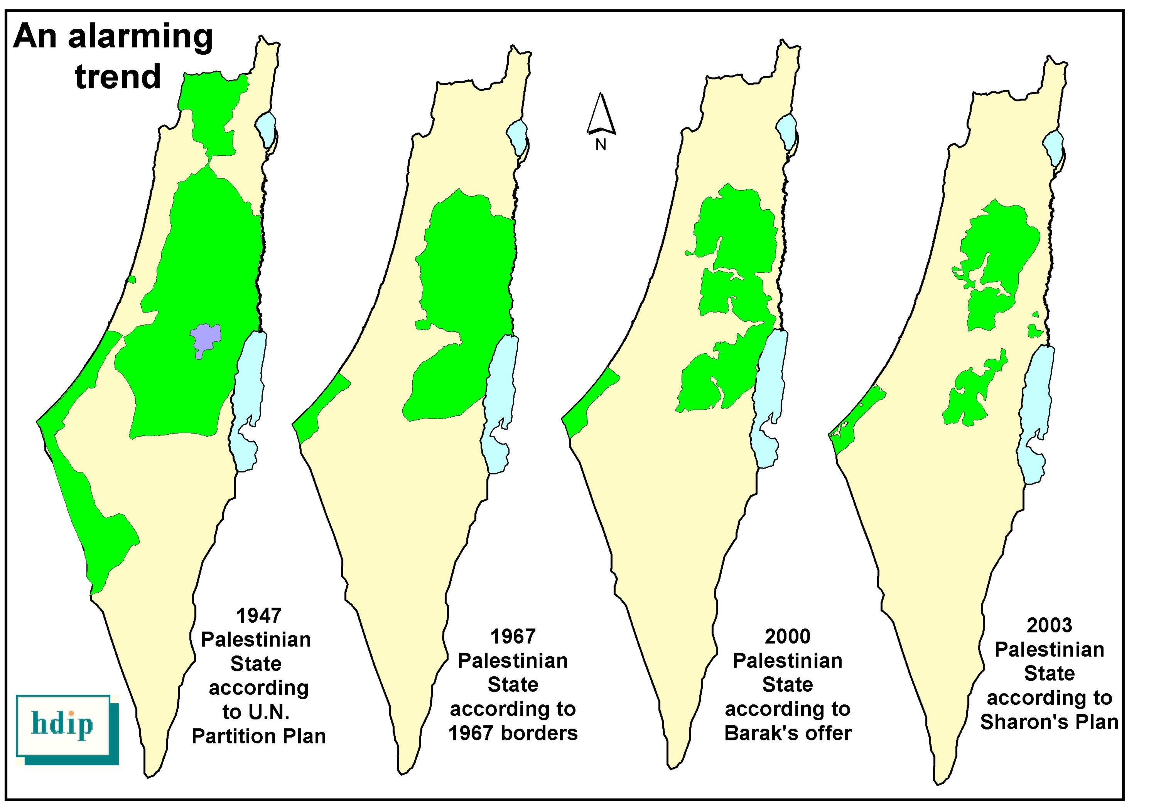

“All States parties to the Fourth Geneva Convention… have in addition the obligation… to ensure compliance by Israel with international humanitarian law as embodied in that Convention”

